# Preface and important points for Energization exercises (EE)

Man’s nature is 3 fold- physical, mental and spiritual (analogous to body, mind and soul). Development of any of these 3 factors depends on the other 2.

## What sustains life in the body

In order to keep bodily cells in motion, certain external factors are necessary.

1. Ultra violet rays of the sun
2. Oxygen
3. Good food
4. Pure liquids such as water and fruit juices

It is not these 4 elements that help body to sustain physically longer, if so people who are having these 4 should be able to live longer or live healthy. Cosmic energy is needed to convert food, liquids and air to keep us alive, and cosmic energy is abundant and our body observes cosmic energy though medulla oblongata (or the “mouth of god”). It is the intersection of neck and skull

medulla oblongata is a vital part of the brainstem responsible for controlling essential functions like breathing, heart rate, blood pressure, and reflex actions. Any surgical intervention in this area carries significant risks due to the critical nature of these functions.

## The relationship between will and energy

A person cannot lift his hand if it is paralyzed, even though he has immense will to lift his body cannot send energy to that part, in the other case, where the hand is working fine, if he sends energy alone to the hand and does not have the will power to lift it, it will not move up, therefore it is proven that will power and energy go hand in hand.

The will can be utilized to develop the body, the will itself is developed in the very process of exercising it, the greater the exertion of will, the greater the flow of energy into that part.

An act of will produces actual energy in body part and in doing so produces tension.

By energizing through will a great link between consciousness, will and the body is found.

The greater the amount of will, the greater the energy in any body part.

### How exactly – an analogy

When in anger humans or animals exert more strength than usual, there is no extra muscle creation for that moment, **the sudden accession of strength comes from the will. Anger simulates the will, and thus causes an extra flow of strength giving energy into the muscles and other body parts**

### Tensing and relaxing

TENSE WITH WILL - By command of will, direct the life force through the process of tension to flood the body or the body part.

RELAX AND FEEL – relax the tension and feel the energy vibrating there, energizing and revitalizing the body or the body part, *feel* that you are not the body, *feel* that you are the life that sustains the body. Feel the peace, the freedom, the increased awareness that comes with the calmness produced by the practice of this method

## Pending

Write the important points of lesson 4 as you are just trying to read it for now

# Do it with the parts of your body THAT which you feel having problem with

To heal any body part, gently tense and relax that part, then tense low, hold that tension, counting 1 to 10 mentally electrocuting the disease by bombarding and recharging that body part with energy. Then relax. Repeat 10 times a day or as often as you desire. Practice healing of any body part while lying down

# Energization exercises

The primary purpose of the exercise is to recharge the body battery with cosmic energy.

Tension results when energy is sent by willpower to any muscle.

LMH tension-

Low – small amount of energy

Medium - more energy

High – **as much energy as possible**

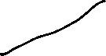

**To obtain maximum results, each exercise should be performed with deepest attention and will power. Keep the eyes closed(eyes may be kept open for few exercises where difficulty is experienced in maintaining one’s balance) and focused upward at the kutastha chaithanya (center between the eyebrows). This center is the polar opposite of medulla center at the base of the brain.**

**The kutastha center is the center of the will in man.**

**#incomplete, look at the lesson 4 and continue this writing #important**

## 1 – double breathing

Count – 3-5 times

Tension - required

Exhale (twice - short and long through the mouth), bend inwards

Inhale, clench your fists when you bend outwards, whilst, tense feet, calves, thighs, buttocks, lower abdomen, upper abdomen, stomach, arms, chest, neck and head in continuous upward direction

Relax in reverse order when you bend inwards

#### Note

Tense body parts together, i.e., both feet, both calves… Do not bend elbows, keep the arms straight

## 2 – leg recharging

Do 2,3 exercises together i.e., after you do left leg recharge, do left leg ankle rotation

Count – 3-5 times

Tension – required

Tense in motion relax at end points

## 3 – ankle rotation

Count: 3-5 times

Tension – Yes (at ankle)

## 4 – calf and forearm, thigh and upper arm recharging

Count: 3 times with left arm and leg, 3 times with right arm and leg, 3 times both arms and legs

Tension - Yes

When you are tensing calf and forearm, clench fist.

One count- tense forearm, calf, then relax. Tense upper arm, thigh then relax

Keep weight on one leg & perform tense and relaxation on another leg

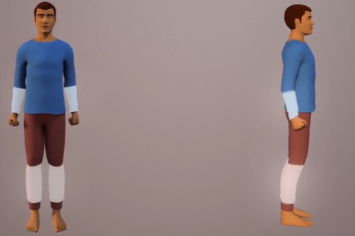

## 5 – chest and buttock recharging

Count: 3 times

Tension – yes

1 count: Tense left chest and left buttock together, relax. Tense right chest and right buttock together, relax.

## 6 – 3 part back recharging

Count: 3 times

Tension – Yes

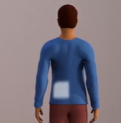

## 7 – shoulder rotation

Count: 3-5 times (forward and then backward)

Tension – NO

## 8 – Throat recharging

Count: 3 times

Tension – Yes

Without raising chin, without applying tension on face

One count involves 3 phases

Phase 1: tense simultaneously all muscles of throat (left, right and front) then relax

Phase 2: tense simultaneously left side and left front, then relax

Phase 3: tense simultaneously right side and right front, then relax

#### Note

Finish this exercise with phase 1 as concluding step

## 9 – Neck recharging

Count: 3-5 times

Tension – Yes

Let chin rest on chest, then tensing neck and throat muscles, pull the chin upward against the tension until the head is tilted back, completely relax the tension so that head falls on its own, as it relaxes and gravity pulls it down, there will be a slight jerk reaction when it pulls down

## 10 – neck adjustment

Count: 3-5 times (rotate 3-5 times in each direction)

Tension – Low

Exert low tension in muscles of throat and neck, slowly rotate head on the neck 3-5 times in one direction, 3-5 times in another direction. Relax

### Note

As a concluding step, rotate head 2 times in one direction, then 2 times in another direction without tension

## 11- spinal adjustment

Count: 6-8 times

Tension - No

Keep your fists closed

Bend your elbows so that forearms are parallel to the ground, keep your fists closed, keep them slightly near to stomach, with a quick jerk, twist your upper body to the lift and hips to the right (this is treated as one count), then twist the upper body to the right and hips to the left (this is treated as another count)

## 12 – spinal rotation

Count- 5 times in each direction

Tension- **slight tension in legs**, tense the **muscles along the back of the spine (check below image).**

Stand with the **legs slightly tensed 12-14 inches apart**, place the hands at the waist. **Concentrate on tensing the muscles of the back along the spine**

Bend the trunk slightly forward,

maintaining the tension along the spine rotate the torso above the waist, five times in one direction, five times in other direction

**do not move hips, the spine up the waist should be rotated, keep the spine above the waist straight**

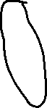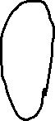

## 13 – Spinal stretching

Count – 3-5 times (side to side)

Tension – tense the muscles along the back of the spine

Sway the torso above the waist, first to one side and then to another, **Bend the spine as far as you can without moving the hips**

## 14 – Spinal adjustment

Count – suggested (4-5), but do as per body support

Stand with feet slightly apart (around 6 inches), fingers (together) of left hand placed on the left side of the spine near the base or the coccyx, and the fingers of the right hand placed on the spine near the base or coccyx

* **Bend the trunk forward slightly, now bend the trunk gently backward simultaneously pushing the lower spine forward with the fingers, arching (making arc shape) the back slightly rising the heels**

Repeat the above step by moving fingers a little higher up the back, continue until you have gone as far up the spine as you can reach

## 15 – spinal twisting

Counts suggested – 6-8 times

Stand with feet apart (at shoulder level, legs not in bending position), **spine tensed,** raise the arms forward to the shoulder level, clench the fists (palms, fingers facing downwards), **tense the arms (from shoulder to fists)** first turn towards left, then to the right, pivoting above the waist so that body above the waist is rotated. The moment should be smooth and rhythmical, not jerky

As the left arm sweeps backwards, right arm should follow and(the elbow should only be bended till that right arm ) touches left shoulder, **relax tension momentarily,** then **tense and twist** to the right, left fist touching right shoulder, **relax again momentarily**. The head should turn following the arc of outstretched arm(left arm in left turn, right arm in right turn) in its backward sweep.

**A twist in one direction counts as one time**

## 16 – memory stimulating exercise

Count – several times

Tension – not required, but feel the stimuli and awakening of brain cells

Briskly rap the entire skull with the knuckles. **Concentrate deeply on each rap and feel that it is stimulating and awakening the brain cells.** This exercise is great for improving the mental and nerve responses

## 17 – scalp massaging

Count - no count, but repeat it at multiple places so that it covers all parts of scalp over head

Tension - no tension required

Hold the fingertips **firmly** **on the scalp** so that the fingers do not slip on the hair, **move the scalp in rotatory motion.** Do this over the entire scalp (replace the fingers (few times) at different positions so that it covers entire scalp and repeat the same rotatory motion). This exercise will loosen muscular tension in the scalp and simulate blood circulation there.

## 18 – medulla oblongata massaging

Count – 2 to 3 times

Tension - required in throat and head, after you move fingers in both the directions

Place the first 3 fingers of each hand on the medulla oblongata at the base of the skull, pressing firmly against the medulla, move the fingers in small circle, three times in one direction, then three times in opposite direction, **with the throat and head tensed as in the neck recharging exercise, draw the head backward, then relax and push the head forward with the fingers so that chin drops quickly (but gently) to the chest**

## 19 – Biceps recharging

Count – each arm, alternately, 3 times

Clasp the (fingers of the ) hands over the head - you may rest on top of the head if you wish – and alternately tense and relax biceps in each arm

## 20 – four part body recharging

Count - all 4 steps 1 or 2 times

### Part 1

Tension – LMH (tense focussing on centre of the part that you are tensing)

Inhale deeply one short and one long breath, and **simultaneously and slowly exert tension from low to medium to high** in all body parts, **Vibrate with energy for 3 seconds**, Throw the breath out in one short and one long exhalation and **simultaneously and slowly relax** **from high to medium to low, feel the energy coursing through the entire body**

### Part 2

Tension – LMH (tense focussing on centre of the part that you are tensing)

**Tense and relax each of the 20 body parts individually, take about 4 seconds to tense and relax each individual part in the following order**

1,2 – left foot, right foot

3,4 – left calf, right calf

5,6 – left thigh, right thigh

7,8 – left buttock, right buttock

9,10 – lower abdomen, right abdomen and stomach

11,12 – left fore arm, right fore arm

13,14 – left upper arm, right upper arm

15,16 – left chest, right chest

17,18 – left side of the neck, right side of the neck

19,20 – front of the neck, back of the neck

### Part 3

Tension – LMH

Part 3 is for tensing and part 4 is for relaxation, part3,part4 are done immediately one after the other

**Tense consecutively(one after the other in the above mentioned order from 1 to 20)** each of the 20 body parts, **holding the tension in each one as you progress**, until the whole body is tensed (**this should take about ten seconds**). As you **begin the tension, simultaneously begin slow inhalation (**not double inhalation**),** if you have not taken in all the air your lungs can hold, without undue strain, **by the time all the parts are tensed continue to inhale to capacity, the body should be tensed so that it literally vibrates with energy. Hold the tension and breath and vibrate for 3 seconds**

### Part 4

Relaxation – HML

Exhale the breath quickly, **simultaneously relax the four parts of the neck and drop the chin to the chest.** But continue to maintain tension throughout the rest of the body. Then relax the other body parts individually, in reverse sequence (from 16 to 1) until the whole body is relaxed. Remember to relax one part at a time (maintain tension in each body part until its turn to relax), if while relaxing the above parts of the waist, you might find relaxing parts below the waist, then simultaneously tense these parts again and relax them one after the other (in the specified order) the enter relaxation should complete in ten seconds. After the upper body parts are relaxed you can maybe lift slowly your head to upright position as the lower body parts are relaxed

### Additional note

This four part body recharging exercise **can be repeated any number of times**, throughout the day in sitting or standing or reclining position or in supine position (lying on the body facing up, similar to shavasana), while keeping your body in standing position, you need to maintain minimum tension in legs, neck in order to hold the body up right, so if you do this exercise in supine position before you rise out of bed, this will set the gear for day’s activity

## 21 – arm recharging (up and down)

Count – 3-5 times

Tension - required

Keeping elbows at sides, raise both fore arms (fists facing each other) with tension as though lifting weights until fists are at shoulder level, relax momentarily, tense again and let the imaginary weights down, relax and repeat, this exercise is performed rhythmically lifting and lowering weights.

## 22 – double breathing exercises (elbow touching)

Count – 3-5 times

Tension – required

With **arms outstretched shoulder level, with elbows bent so that forearms are perpendicular to the ground (as if your fists, fore arms and shoulders are forming |_._|** ), bring arms forward with a sweeping motion so that elbows, forearms and fists meet. At the same time, exhale twice relaxing the body and slightly bending the knees. Hold to the count of 3. Inhale twice and tense the body parts in upward order, at the same time bringing the bent arms to the starting position. Hold to the count of 3. Exhale twice and relax the 20 body parts in reverse order while bringing the forearms front together and slightly bending the knees. Hold to the count of 3, remember to keep the spine straight, the elbows at shoulder level and the forearms perpendicular to the ground at all times during the exercise. Palms of fists are towards (each other) sides of the head in tensing position of this exercise. Palms of fists face forehead in relaxing position

While moving outside a wave of tension from bottom to up happens, while moving inside a wave of relaxation happens from up to bottom

## 23 – arm recharging (from shoulders)

Count- 3-5 times

From a starting position in which the arms are extended sideways at shoulder level with the elbows bent so that the fists are at either side of the head, extend the forearm outward to the side, with tension, keeping the upper arms at shoulder level. Relax tension momentarily. Then tense the arms and draw them back to the starting position; relax tension. **This exercise should be done as though the arms are pulling and pushing heavy weights toward and away from the sides of the head. Palms of fists face upward in the extended position and downward when at the sides of the head.**

## 24 – arm rotation (small circles)

Count – several times in each direction

Tension - required

Extend the arms fully outside (straight parallel to the ground fists facing up), clench the fists tightly and tense the whole arm. Tense the arm, and start rotating the arms (in one direction) and while you rotate, increase the tension in LMH fashion, after reaching high, after 1-2 seconds, relax momentarily, then rotate in other direction following same steps

## 25 – arm recharging (from forehead)

Count – 3-5 times

Tension – required

With upper arms outstretched in front of the body at **shoulder level** and elbows bent so that the fists are lightly touching the forehead (facing each other throughout the exercise) **tense the arms** and extend them forward, **relax momentarily, tense** and bring them back to the head as in the starting position. Relax momentarily and repeat. This is done as though alternately pulling and pushing a heavy weight to and from forehead.

## 26 – four part finger recharging

Count – several times in each position

Tension – required

With arms straight down to the either side of the chest, **tense the fingers and keep the tension, rapidly open and close the fists. Repeat the same with arms extended to the sides at shoulder level, palms turned downward.** **Repeat with arms straight out in front of the shoulder, palms facing downward. Repeat with arms raised above the head, palms facing forward**

**Note:** fingers should be fully stretched as much as it can be without stress

## 27 - four part arm recharging

Count – 3-5 times

Tension – required

Start with arms down at sides. With tension in arms, bend at elbows so that fists come up to the chest (fingers towards the chest), reduce tension then increase again extending arms to the side at shoulder height, reduce tension, exert tension again to draw fists back to the chest, reduce tension, again thrust arms forward at chest height, reduce tension, exert tension again as you bring fists back to the chest, and reduce tension, finally extend the arms upward over the head, stretching up on the toes, **tensing whole body** and simultaneously inhaling twice. Relax tension and exhale twice as fists are lowered first to chest and then to starting position at the sides. Palms of fists face downward when arms extended from sides and in front, forward when arms are extended over head

## 28 – raising arms with double breathing

Count – 3-5 times alternately, each arm

Tension – required

Without bending the elbows, tense the arm and swing it forward and up until perpendicular to the floor, inhaling twice and raising on toes at the same time. Exhale a double inhalation and put heals back on the floor as arm is relaxed and brought down in forward motion. Repeat the same with left arm

Note:

Tense the arm while going up, relax it while coming down

## 29 – Lateral stretching

Count – 3-5 times each side alternately

Tension required – no

Stretch trunk left as far as possible, bringing **right arm** **straight up** to the side of the head and stretching **left arm down as far as possible at the side of the left knee as you bend in that direction**, then stretch to the right side in same manner, with the left arm up by the head and the right hand down by the right knee, alternate the left and right stretch

## 30 – walking in place

Count – 25-50 times

Tension - required

Lift your left leg and right arm, then right leg and left arm in an alternate fashion, while lifting opposite leg and hand , **tense the whole leg including thigh muscles and the back, at the same time tense the opposite arm and bringing the fist up to the chest,** while bringing up tense the limbs, while moving them down relax the limbs, **this exercise has to be done in place, and it should seem as if you are marching in the same place**

## 31 – running in place

Count – 25-50 times

Tension – not required

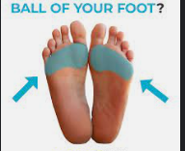

Run in place, with a light springy step but exaggerate the motion by bringing the **heels up in back so as to strike** **the buttock. Run on balls of the feet** so as to avoid jarring the body. **Try to maintain natural rhythm, arms with elbows bent (front arm with the fist can be parallel to the ground) should remain in stationary position.**

## 32 – fencing exercise

Count – 3-5 times each side , alternately

Tension – required

Bend arms at **elbows so fists are on the chest**. **Tense the left leg and step forward with it about ten to fourteen inches ahead of the right foot**; the **left knee should be slightly bent**. Keep the right leg straight and tensed with the heel flat on the floor, **simultaneously clench the fist of the right hand and tense the right arm extending the straight out from the chest exhaling twice. There should also be great amount of tension in the chest. Slowly relax the tension as the foot and arm are brought back to the starting position, and inhale twice.** Repeat alternately with the opposite foot and arm. **At all times during this exercise spine and head should be erect perpendicular to the floor. When the arm is thrust forward, the wrist and arm should be in a straight line, not bent; and the palm of the right fist should be turned toward the left and vice-versa**

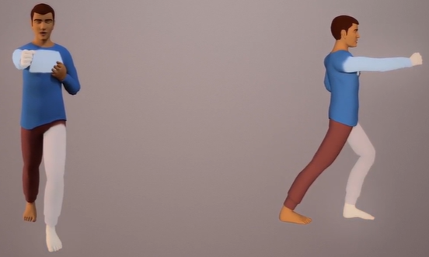

### Doubt

Tensed heal on the floor?

## 33 – arm rotation (large circles)

Count – 3 times in each direction

Tension – LMH

With arms hanging straight down at sides, **clench fists, tense arms, rotate arms in a circular motion**. First bring them forward and up, as if making the first part of larger circle **increasing the tension till they are directly overhead.** then **begin to relax them slowly as they are brought down as far behind the trunk as possible, completing the circle,** **after three times rotate in the opposite direction.**

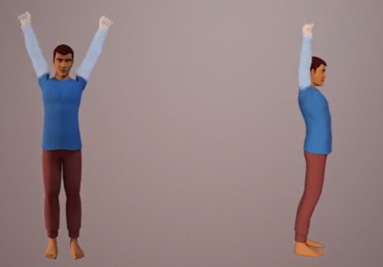

## 34 – stomach exercise

Count – 5-10 times

Tension – required

Benefits – reduces indigestion and constipation

Place feet about ten inches apart. Incline the trunk forward, keeping the spine straight, but at an angle. Bend the knees slightly. **Place the most weight of torso (trunk) on the hands**, which should be resting with the palms flat on the thighs or at a little below the junction of thigh and abdomen.

**Exhale breath twice and, without inhaling**, draw the abdomen and stomach in and upward (this motion is assisted by the partial vacuum in the chest cavity). Force the abdomen (the stomach, liver and intestine part) and stomach out gently and slowly. Draw in and force out again. Take another breath, exhale and repeat

With practice, you may increase from 2-10 number of times the abdomen and stomach are drawn slowly in and pushed out without taking another breath. But do not hold breath to the point of discomfort.

Never practice this exercise with a full stomach (wait 2 hours after eating) or practice before eating, women should not practice this exercise during pregnancy.

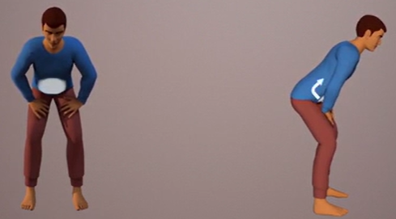

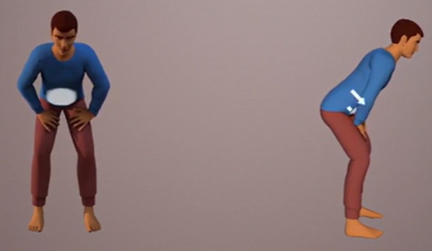

## 35 – repeat exercise 1- double breathing exercise (with tension)

Count – 3-5 times

## 36 – repeat exercises 2 and 3 - leg recharging and ankle rotation

Count – 3-5 times each

## 37 – leg rotation

Count – 3-5 times in each direction.

Tension – no

Note: large clockwise rotations and normal anti clockwise rotation, first left anti clockwise, then left large clockwise, right large clockwise, right anti clockwise

Stand with the weight on the **right foot**, keeping the left leg straight, swing it out in front, to the left, to the rear, and back to the starting position, in a counter clockwise 3-5 times, then rotate the same leg 3-5 times in a large clockwise circle. Shift the weight to the left foot, holding the right leg straight, swing it in a large clockwise circle, then reverse direction to counter clockwise rotation

## 38 – double breathing exercise without tension

Count – 3-5 times

Tension – NO

Exhale twice to expel all the breath, extend arms straight forward from shoulders, hands open and fingers extended, hold the breath out to the count of 12, as far as long as is comfortable. **Concentrate the mind on calmness and on freedom from breath.** Then inhale twice, taking in all the breath you can hold without straining; simultaneously, bend arms at the elbows to bring hands back to the shoulders (fists closed), hold again to the count of 12, or as long as far as is comfortable, **again feeling the great calmness that comes with the cessation of breath. Neither the torso nor the limbs should be tensed in this exercise. Maintain erect posture with arms extended**

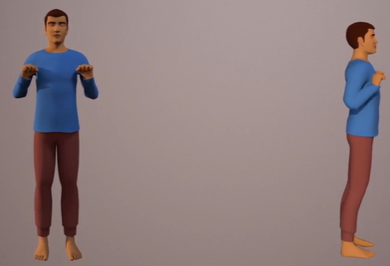



# Doubts as a whole

Lmh tension required wherever there is a mention of tension?

# Tasks down the lane

Make the exercises more interesting by snipping critical parts from animation video

Also make a note of critical points while you re-read the exercises and pre-logue